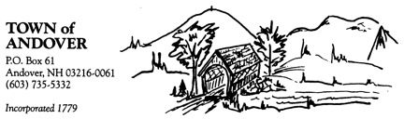

ZONING BOARD OF ADJUSTMENT
AGENDA
TUESDAY, May 17, 2022
7:00 P.M.

7:05 p.m. | Public Hearing – to consider a request from Laurel Shinerock and Tristan Rocher for a Special Exception as specified in the Andover Zoning Ordinance Article V Section 2(a) to permit the construction of a single-family dwelling on an existing lot. The property is located on Bradley Lake Road, Tax Map 6, Lot 284,527 and is in the Forest / Agricultural Zone.
7:25 p.m. | Continuation of Deliberations - to consider a request from Nicholas C. Robinson for a Special Exception as specified in the Andover Zoning Ordinance Article 5 Section A to allow a landscaping business operation and workshop. The property is located on Route 4A and is Tax Map 28, Lot 386,337 in the Forest & Agricultural Zone.
7:45 p.m. | Review of minutes from April 19, 2022 meeting and continuation  of Board discussion related to updating forms and procedures.
7:55 p.m. | Other Business and Adjournment

