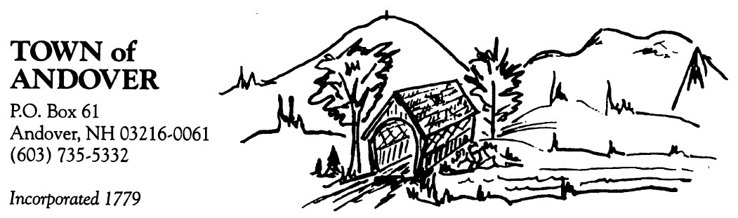

Andover Zoning Board of Adjustment
Fee Schedule
Adopted 9/17/2013

Application for:

Appeal from an Administrative Decision $50

Special Exception $50

Variance $50

Equitable Waiver of Dimensional Requirements $50

Certified Mail Notice to Abutters or Towns – each $9
Non-Certified mailed notices to Towns – each $1

Newspaper Notices–estimated cost to be collected with application $125
(actual cost if greater will be billed, if lower refunded if over $5)

Printed Copies of Zoning Ordinance $10

Downloadable Copies of Zoning Ordinance NO CHARGE
Available at andover-nh.gov
Click on Zoning Board of Adjustment or Planning Board

